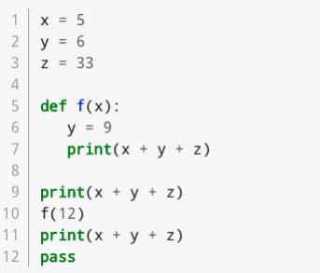

1. **What is the output of the program?**

44

54

44

1. **Which line contains a function header?**

Line 5

1. **Which line(s) constitute the main program?**

Lines 5, 7, 9 , 10 and 11

1. **Is there a local variable defined anywhere? If so what is its scope?**

Yes (y), it is defined in the custom function (f)

1. **Does the function f return a value?**

Yes

1. **Does the function f reference any global variables?**

Yes, z and y

1. **Which lines constitute a function body?**

Lines 5, 6 and 7

1. **Are there any arguments used in the program? If so what and where are they? (tricky)**

Yes, that is x in line 1 , y in line 2 and in 6 and z in line 3

1. **Are there any parameters defined in the program? Explain.**

Yes, variable x in line 5 is a parameter since its value is assigned to the function when the function is called.

1. **What does the last line do?**

Acts as a placeholder when a programmer wants to use loops in the future code.